Objectives:

* Creating functions.
* Setting and passing arguments.
* Creating global variables.

**There are 5 print screens, each worth 20%**

Please submit this document for grading when completed… Please work in-groups.

A function is a name that you can call, and within a function are code statements. It’s a neat way to break down your code.

**Project #1** (here we create two function message1 and message2). We use the keyword **def** to use a function.

**Project #2** (using an input and output in a function)

**Project #3** (calling the first function and in between functions)

**Challenge Exercise #1**: using project #3, add to the code so that the user can enter or input the number of birds in each state.

**#1 print screen the output with code below here.**

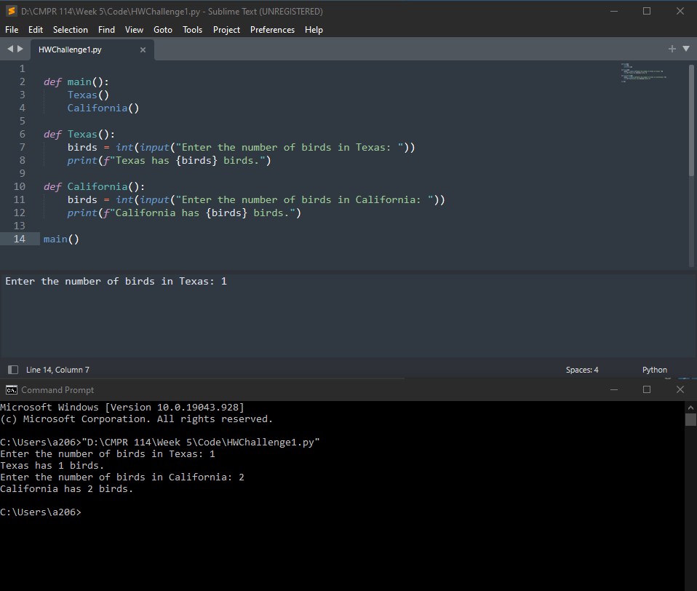

**Project #4** (passing string arguments to a function).

**Challenge Exercise #2:** Create a program with a *function* that will allow the user to enter the last, first names, address, city, state, with zip code.

**#2 print screen the output with code below here.**

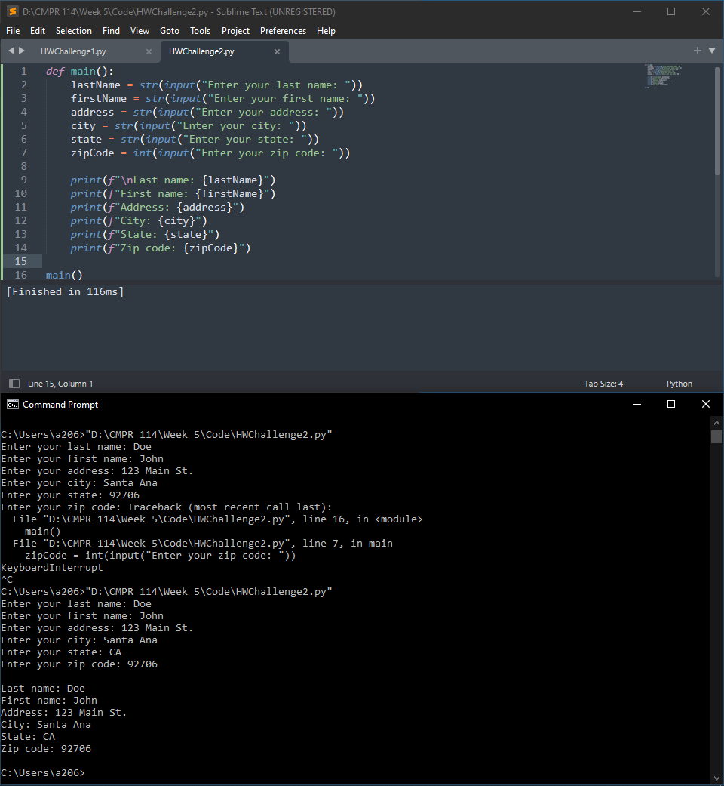

**Project #5** (Creating a global variable)

A global variable is used using the global keyword, and it’s a variable that can be seen anywhere on the program. See the code below.

**Project #5 continued**, using global variables, this example will add 3+4 using a function named add.

Now, cut and paste print(total) below add (3,4). Notice the error appears because it is not a part of the function no more.

To fix this, you can use the **return** word in this local variable and assign a local variable of (a) and print (a).

Now, let’s talk about a global variable. To use a **global** variable, use the global keyword. Notice, that we the total global variable can be seen anywhere in the program, since its global.

**Challenge Exercise #3:** Modify the project #5 to add three numbers.

**#3 print screen the output with code below here.**

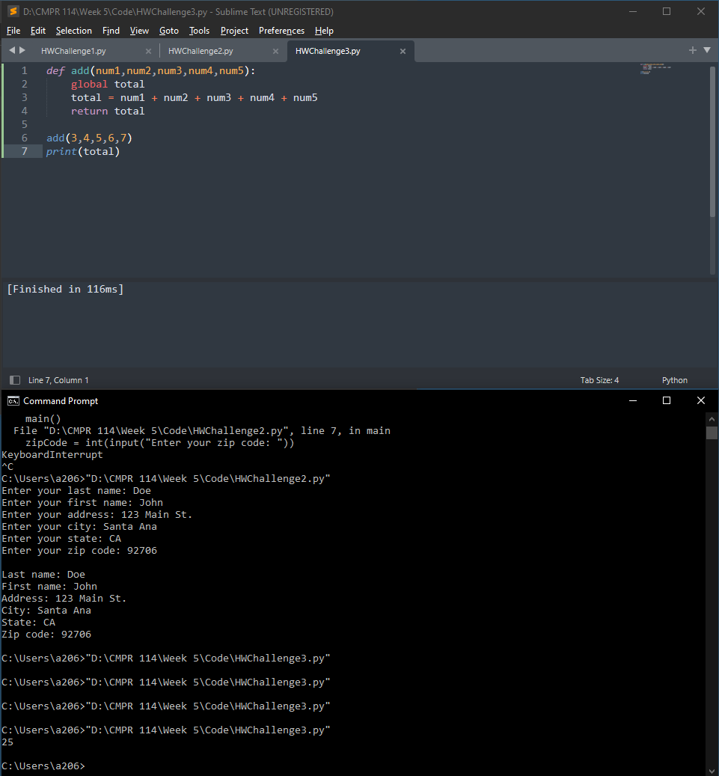

**Challenge Exercise #4:** Modify the project #5 so the user can enter or input any three numbers, be sure to use global variables in the program. Also, sum and average the three numbers.

**#4 print screen the output with code below here.**

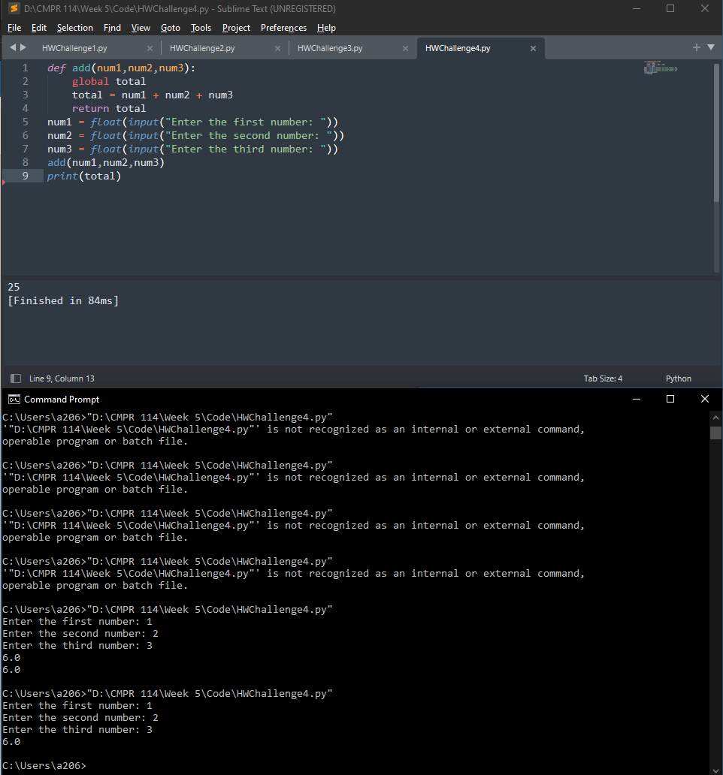

**Project #6** (using a global constant, which means a global variable where a parameter or a number is assigned).

**Challenge Exercise #5:** using a **function** and **setting** and **passing** **arguments**, create a program that will ask the user to enter the hours worked, and hourly pay. Then get the output in a print statement.

**#5 print screen the output with code below here.**

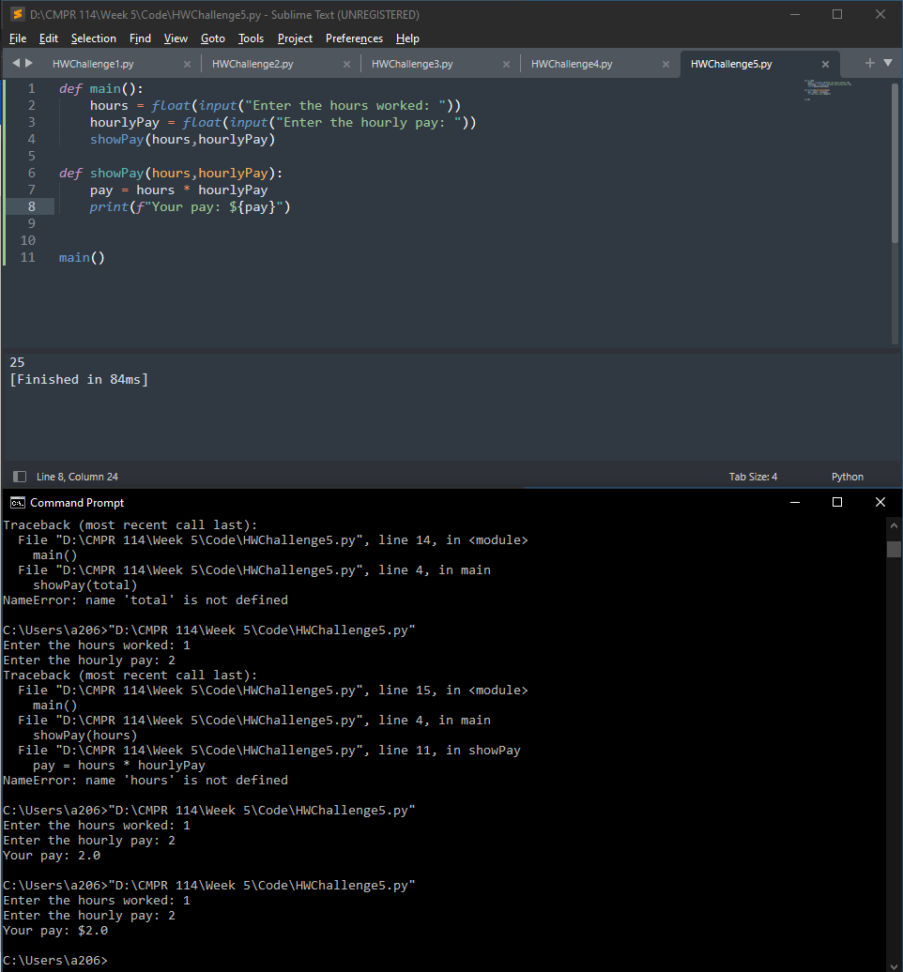

**Submit this document to Module 5 Class Exercise.**